NAME:- MUHAMMAD ZOHAIB AHMER. (FA20-BCS-038)

SANAN (SP20-BCS-038).

DATED :- 2023.12.27

CC LAB TERMINAL

Q2: Which functions is used ??

ANS:

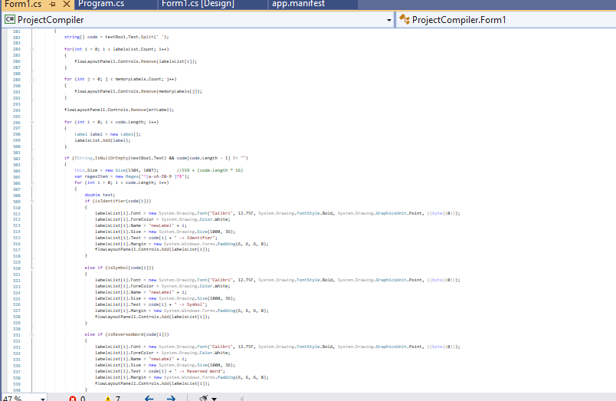

Output:

